Associate in Arts Degree: Modification
Bookkeeping
Criteria A. Appropriateness to Mission
- Statement of Program Goals and Objectives:
This program will continue to offer completers the opportunity to be employed in entry level positions in bookkeeping.
Program Student Learning Outcome: ​ ​
Upon completion of this program, the student will be able to analyze and record business transactions using double-entry accounting as well as construct and interpret required financial statements.
Catalog Description:
Accounting offers theoretical and practical courses for students planning to transfer as accounting majors, career and technical courses that lead to certificates of proficiency and achievement, and professional development courses designed to improve workplace skills. Career options in accounting include positions in the private and public sectors, tax preparation, finance and banking, business ownership, and management.
A bookkeeper generally works under supervision. He/she makes entries in special journals, posts to subsidiary ledgers, and verifies and files source documents. Appropriate training includes accounting, business mathematics, and computer office skills.
A strong demand by the community for bookkeepers assures opportunities within this field. The following courses may be taken in any sequence as long as all prerequisites are met.

- Program Requirements: Program Courses (26-28 Units)
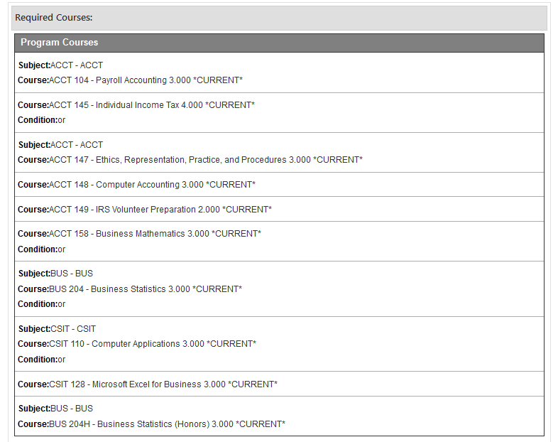

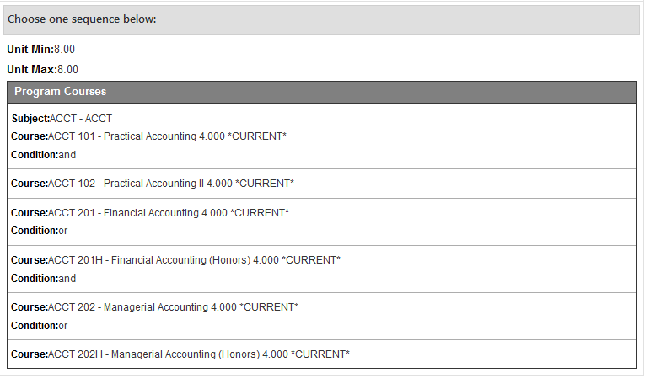
- Master Planning
This program is consistent with the college’s master plan and is not considered a substantial change by the college’s accrediting agency, Accrediting Commission for Community and Junior Colleges (ACCJC).

Criteria B. Need
- Enrollment and Completer projections:
Course Number |  | 2021-2022 |  | 2022-2023
 |  | Sections | Enrollment | Sections | Enrollment
ACCT | 104 | 4 | 96 | 4 | 96
ACCT | 145 | 4 | 120 | 4 | 120
ACCT | 147 | 4 | 120 | 4 | 120
ACCT | 148 | 6 | 144 | 6 | 144
ACCT | 149 | 4 | 120 | 4 | 120
ACCT | 158 | 4 | 160 | 4 | 160
ACCT | 101 | 10 | 400 | 10 | 400
ACCT | 102 | 1 | 40 | 1 | 40
ACCT | 201 | 20 | 800 | 20 | 800
ACCT | 202 | 20 | 800 | 20 | 800
BUS | 204 | 12 | 420 | 12 | 420
CSIT | 110 | 10 | 240 | 10 | 240
CSIT | 128 | 6 | 144 | 6 | 144

- Place of Program in Curriculum/Similar Programs
This program is included in the Business Department program offerings requiring courses that are already in the department’s course inventory.
- Impact on Other Colleges in Service Area
No impact determined after review and approval by the Region 10 occupational deans that include the deans of San Diego Miramar College, Palomar College, Cuyamaca College and Southwestern College. Southwestern College, Palomar College and Cuyamaca College have automotive technology programs. The certificate of achievement and associates degree were recommended for approval by the Region 10 (San Diego and Imperial County) Career Education Deans at their February 8, 2021 meeting.

ADDITIONAL SUPPORTING DOCUMENTATION – CTE
- Labor Market Information and Analysis
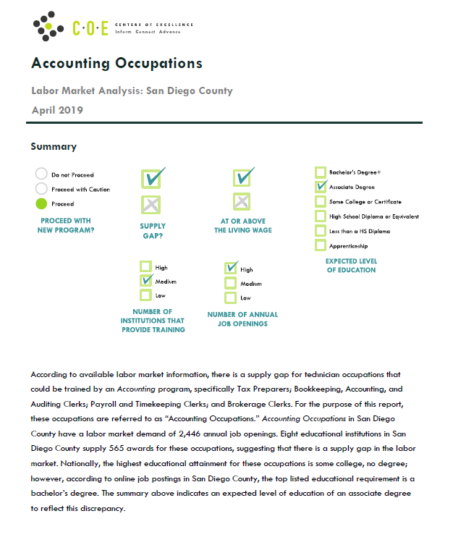

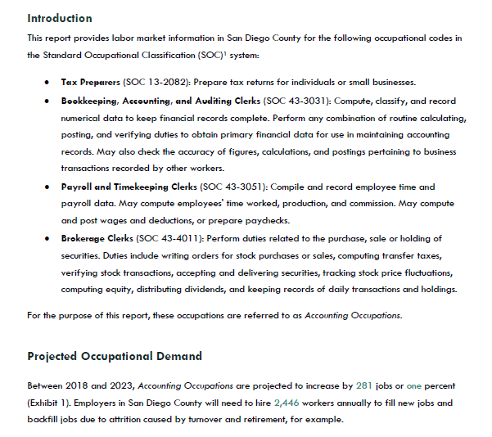

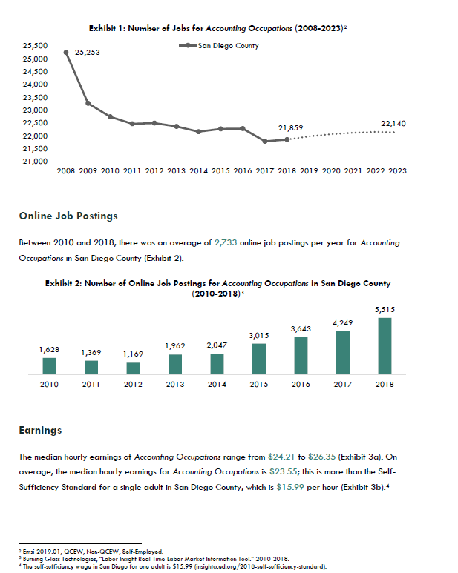
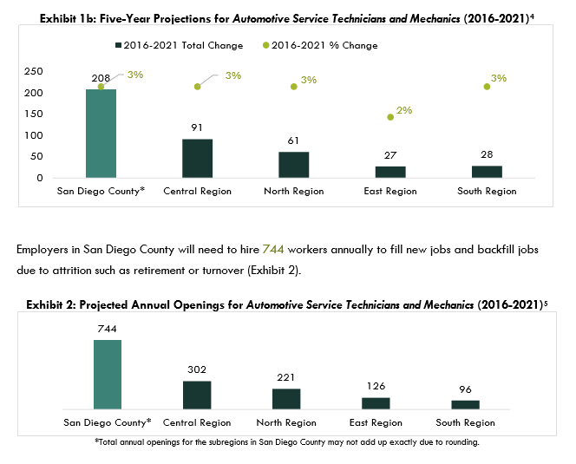

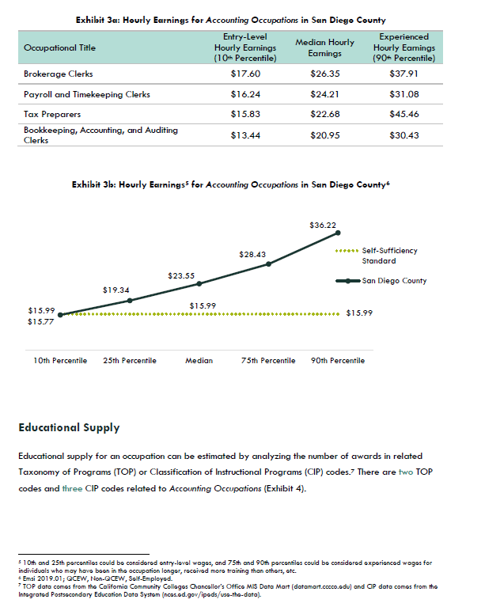

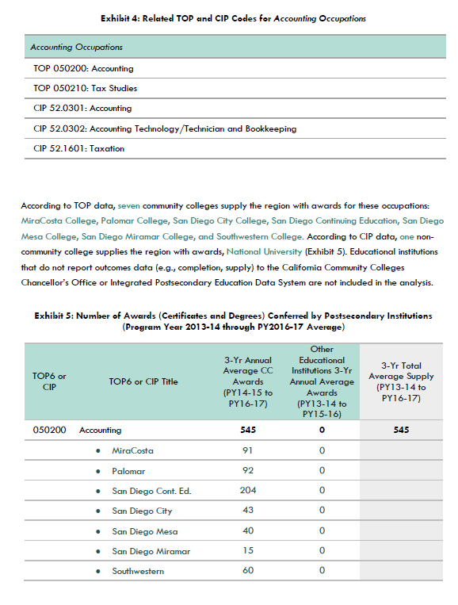

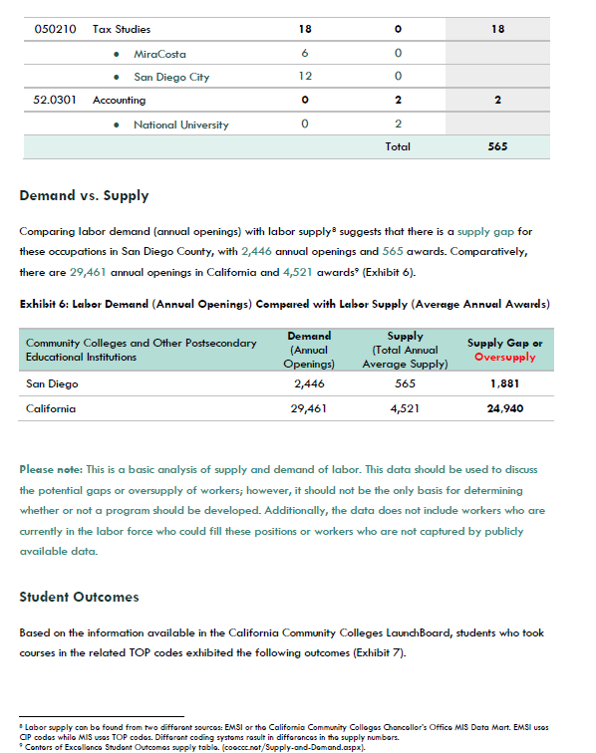

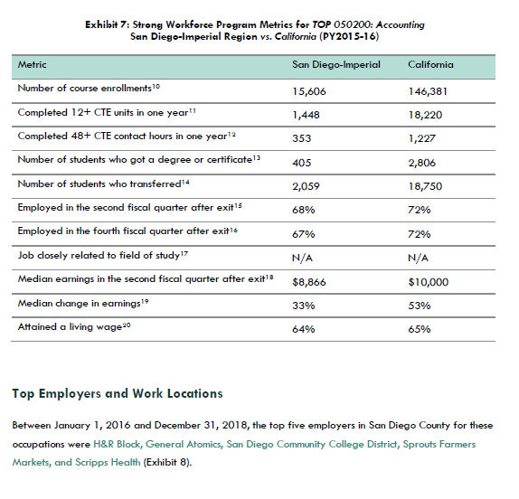

Job Postings
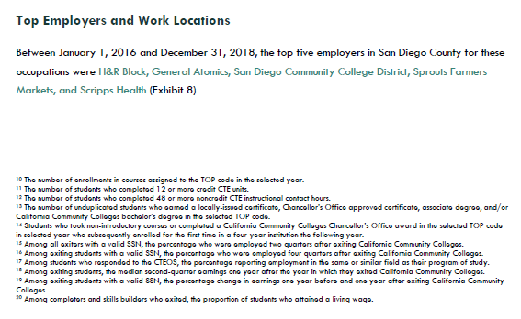
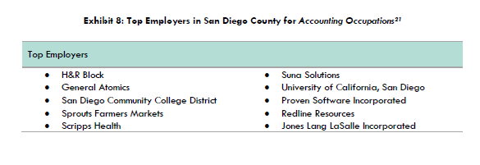
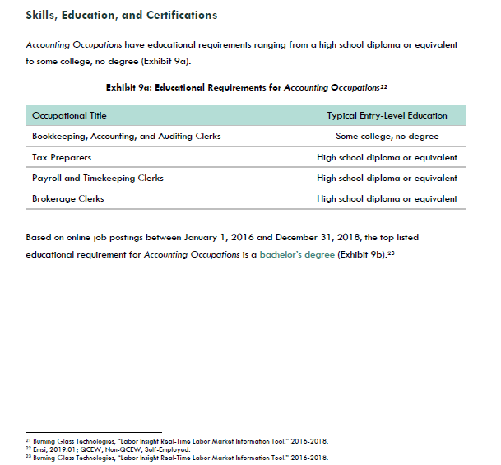
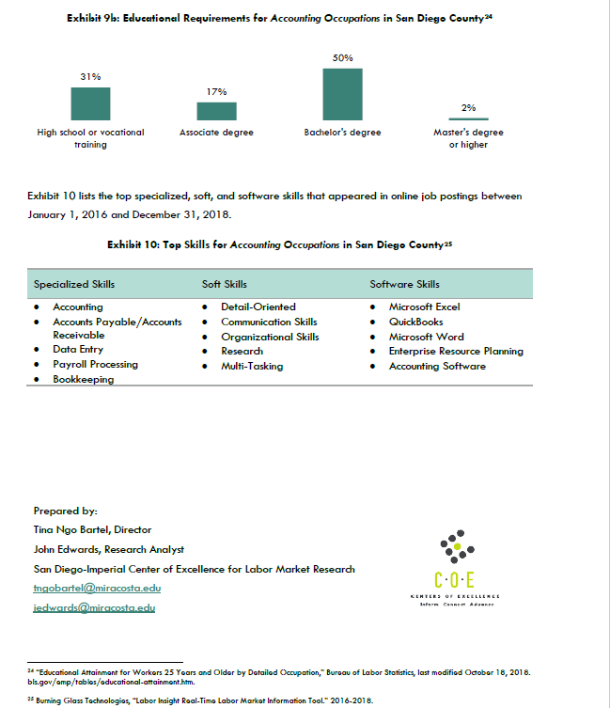

*NOTE: Entire Center of Excellence for Labor Market Research Study is attached to the submission.

2. Advisory Board Recommendation
Advisory Board approved the addition of this certificate of achievement via an e-mail vote taken in April 2020. Those e-mail minutes are included in the CCCCO submission.
3. Regional Consortia Meeting Approval Minutes
Regional Consortia meeting February 8, 2021 meeting minutes indicating recommendation of this program modification are attachment to the submission to CCCCO.

